Bid Specifications for Community Center Kitchen Remodel

Bob Cerasuolo Park Services Manager Pleasant Valley Recreation and Park District, Camarillo, CA 805-482-5396 ext 301 bobc@pvrpd.org www.pvrpd.org

Invitation to Bid:
Due August 17, 2021 at 10:00 am

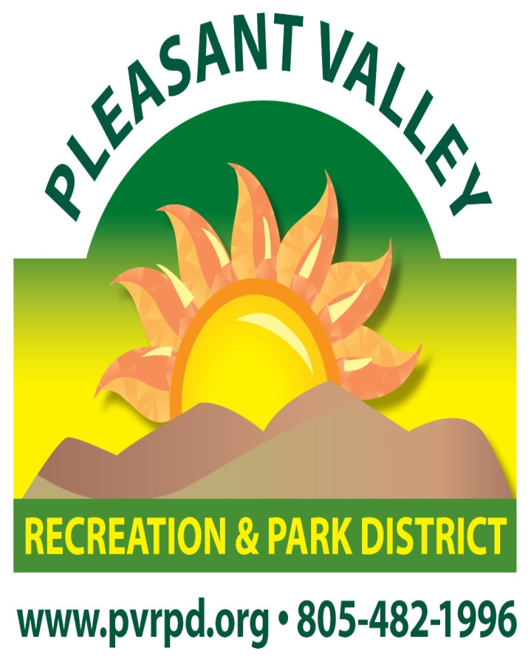

Invitation to bid

Pleasant Valley Recreation and Park District (“District”) is seeking bids for the remodeling of the kitchen at the Community Center at 1605 E. Burnley St. Camarillo CA 93010 to the specifications. There will be a mandatory job walk on July 26, 2021 at 9:30 am.

DESCRIPTION OF WORK:

- Scope of Demolition and Removal Work is shown on drawings
- Installation of Partition Walls/Support Framing and Soffits
- Remodel the Community Center Kitchen Per Plans
- Plumbing: New Construction Per California Plumbing Code
- HVAC: Protect Existing Type 1 Hood in Place Verify Hood/ Make up Air / Hood Filter Per Plans
- Electrical Power and Lighting: New Construction Per Code Requirements
- Fire Suppression Sprinklers: Existing to Be Rehabilitated / Certified
- Fire Alarm: Existing System
- Painting and Drywall
- Tile Work over Concrete slab and Cementitious Backer Board
- Installation of Appliances (purchase by others) Installed by Contractors

BASIC OF SPECIFICATIONS
Refer to manufacturer’s specifications unless otherwise noted herein, the basic of specifications for this project shall be Per 2019 California Building Code and Current Amendments.

Proposal Process

The proposal process will consist of a written presentation (4 copies). The following shall be included in your written proposal:

- A breakdown of the work to be done. By Trade, Based on G.S.I Divisions.

- History of similar projects completed within the last seven (7) years, including cost and client contact information.

- Provide a minimum of three (3) references including service provided, name of agency, contact person, phone number and email.

- Description of the proposed schedule and the approach that will be used to organize and prepare for the work to be done.

Evaluation of BID Proposals

District staff will review the proposals. The selected Contractor will be contacted to let them know they have been awarded the bid.

The evaluation of proposal will be based on the following:
- Completeness and thoroughness of information provided and adherence to deliverables.
- Ability to meet budget, although cost will not be the sole factor.
- Ability to comply with all State, Federal and local regulations.
- Ability to possess a California State Contractor License with a classification of a “B” and a City of Camarillo business license and the proper insurance and bonding.
- Ability to possess a D.I.R. number

The Pleasant Valley Recreation and Park District Board of Directors will make the final award. No other officer or agent may obligate or bind the District.

CONSTRUCTION SCHEDULE

Within ten (10) days of the District’s Contract award, the contractor shall submit a Preliminary Construction Schedule, outlining the various items of work.
Contract award September 1, 2021
Project start date approx. September 20, 2021
Project completion date no later than January 23, 2022

HOURS OF OPERATION
Unless otherwise approved by the General Manager, the Contractor shall not work outside the following Hours of Operation on this Project:
Weekdays (M/T/W/TH/F): 7:00 AM - 7:00 PM
Weekends (Sat. & Sun.): 7:00 AM – 7:00 PM; upon District approval
Holidays: No Work. (Holidays are those Holidays observed by the District)
DESCRIPTION
The work to be performed under this Specification, No. 2021-02 consists of furnishing, by the Contractor in accordance with the contract drawings and specifications and subject to the terms and conditions of the Contract, all materials, equipment, tools, labor and incidentals necessary for the construction of the proposed project, complete and in place.

TIME LINE

Request for Bid Proposals released: July 11, 2021
Mandatory job walk: July 26, 2021 9:30 am
Questions in by: August 10, 2021 12:00 pm
Proposals must be received by: August 17, 2021 10:00 pm
Contract award: September 1, 2021
Project approx. start date: September 20, 2021
Project completion date no later than: January 23, 2022

PROPOSAL DEADLINE

The deadline for the bid proposal is August 17, 2021, 10:00 am. Proposal must be submitted in a sealed envelope marked Bid Community Center Kitchen Remodel, by the deadline. Proposal must be signed by an authorized individual to bind the firm and be valid for at least 60 days.

Please submit four (4) copies of the proposal to:

Bob Cerasuolo,
Park Services Manager
Pleasant Valley Recreation and Park District
1605 E. Burnley Street
Camarillo, CA 93010

FAXED or ELECTRONIC RESPONSES WILL NOT BE ACCEPTED

Additional Information

For questions contact: Bob Cerasuolo, Park Services Manager
805-482-5396 ext. 301
E-Mail bobc@pvrpd.org

