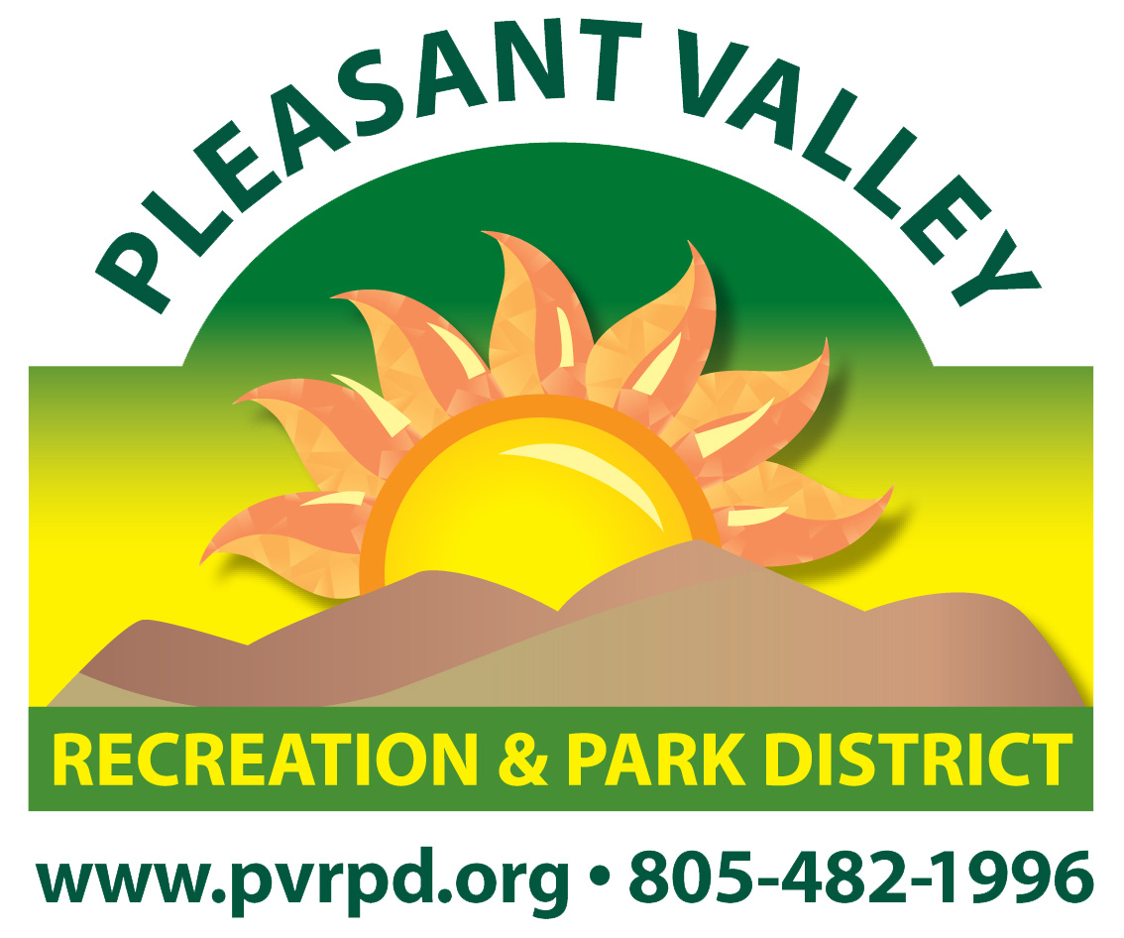
PLEASANT VALLEY RECREATION & PARK DISTRICT

SUMMER SOFTBALL 2022 - ROSTER FORM

1605 E. BURNLEY STREET, CAMARILLO, CA (805) 482-1996 x 201

Team Name: Night: Alt. Night:

Manager: Cell Phone: Alt. Phone:

Street Address: City: ZIP:

Email Address: League Request (Circle One): C- or C or C+
Note: 12 players minimum. 20 players maximum.
All information must be clearly legible, accurate, and verifiable.
Team Manager & Players: Please complete both sides of this form.

# | Player Name | Home Address | City | ZIP | Cell Phone | ShirtSize
1
2
3
4
5
6
7
8
9
10
11
12
13
14
15
16
17
18
19
20
Players under 18 must comply with California State Law, AB2007 regarding concussions and head injury.
Parent Authorization Forms can be found online at pvrpd.org under Adult Sports.
Update:

Softball forms and schedules can be found online at pvrpd.org under Adult Sports.

OFFICE USE ONLY

Entry Fee: $ Date: Time: Receipt: # Initials:
SOFTBALL LEAGUE - AGREEMENT, WAIVER, AND RELEASE

In consideration for being permitted by the District to participate in the above-referenced activity, I hereby waive, release, and discharge any and all claims for damages for personal injury, death, or property damage which I may have, or which may hereafter accrue to me, as a result of participation in said activity. This release is intended to discharge in advance the District (including its officers, employees, volunteers, and agents) from any and all liability arising out of or connected in any way with my participation in said activity, even though that liability may arise out of active or passive negligence or carelessness on the part of the persons or entities mentioned above.
It is further agreed that this waiver, release and assumption of risk is to be binding on my heirs, administrators, executors, and assigns and that I shall indemnify and hold the District (including its officers, employees, volunteers, and agents) free and harmless from any loss, liability, damage, cost, or expense which may arise out of or connected in any way with my participation in said activity.
Additionally, I fully understand that my participation in the above-referenced activity exposes me to the risk of personal injury, death, communicable diseases, illnesses, viruses, and/or property damage. I hereby acknowledge that I am voluntarily participating in this activity and agree to assume any such risks.
PHOTOGRAPHIC RELEASE: I understand that photographs may be taken during this activity and hereby grant the District permission to use any such photo(s) for advertising or in promotional materials.
I HAVE CAREFULLY READ THIS AGREEMENT, WAIVER, AND RELEASE AND FULLY UNDERSTAND ITS CONTENTS. I AM AWARE THAT THIS IS A RELEASE OF LIABILITY AND A CONTRACT BETWEEN MYSELF AND THE ABOVE DISTRICT AND I SIGN IT OF MY FREE WILL.
Participants under the age of 18 must have a parent signature stating if their youth suffers a suspected concussion or other head injury, the manager must contact the participant’s parents or guardian of the time and date of the injury, the symptoms observed, and any treatment provided.

 | Player Name (Print) | Player Signature | Email Address
1
2
3
4
5
6
7
8
9
10
11
12
13
14
15
16
17
18
19
20

Players under 18 must comply with California State Law, AB2007 regarding concussions and head injury.
Parent Authorization Forms can be found online at pvrpd.org under Adult Sports.
As manager, I assume responsibility for the conduct and sportsmanship of all team members.
All information provided on the front and back of this form is valid and verifiable.

Manager’s Signature: ___________________________________ Date: _________________

